- Weather:
# Load libraries
library(scatterplot3d)
library(plotly)
# Create dataset
date <- as.Date(c('2023-01-01','2023-01-02','2023-01-03','2023-01-04','2023-01-05'))
temperature <- c(10, 12, 8, 15, 14)
humidity <- c(75, 70, 80, 65, 72)
wind_speed <- c(15, 12, 18, 20, 16)
df <- data.frame(date, temperature, humidity, wind_speed)
# 1.Temperature, Humidity & Wind Speed over Time
plot(df$date, df$temperature, type="o", col="red", ylim=c(0,20),
xlab="Date", ylab="Values", main="Temperature, Humidity & Wind Speed")
lines(df$date, df$humidity/5, type="o", col="blue")
lines(df$date, df$wind_speed, type="o", col="green")
legend("topright", legend=c("Temperature","Humidity/5","Wind Speed"),
col=c("red","blue","green"), lty=1, pch=1)
# 2. 3D Scatter
scatterplot3d(df$humidity, df$wind_speed, df$temperature,
color="purple", pch=19,
xlab="Humidity (%)", ylab="Wind Speed (km/h)", zlab="Temperature (°C)",
main="3D Scatter: Temp vs Humidity & Wind Speed")
# 3. Correlation Matrix
print("Correlation Matrix:")
print(cor(df[,2:4]))
# 4. 3D Surface Plot (interactive)
plot_ly(df, x=~humidity, y=~wind_speed, z=~temperature, type="surface",
colors = colorRamp(c("skyblue","orange","red"))) %>%
layout(title="3D Surface: Temperature vs Humidity & Wind Speed",
scene = list(xaxis=list(title="Humidity (%)"),
yaxis=list(title="Wind Speed (km/h)"),
zaxis=list(title="Temperature (°C)")))
# 5. Compare Temperature vs Humidity & Wind Speed
par(mfrow=c(1,2))
scatterplot3d(df$humidity, 1:5, df$temperature, color="blue", pch=19,
xlab="Humidity", ylab="Day Index", zlab="Temp (°C)", main="Temp vs Humidity")
scatterplot3d(df$wind_speed, 1:5, df$temperature, color="red", pch=19,
xlab="Wind Speed", ylab="Day Index", zlab="Temp (°C)", main="Temp vs Wind Speed")
output:
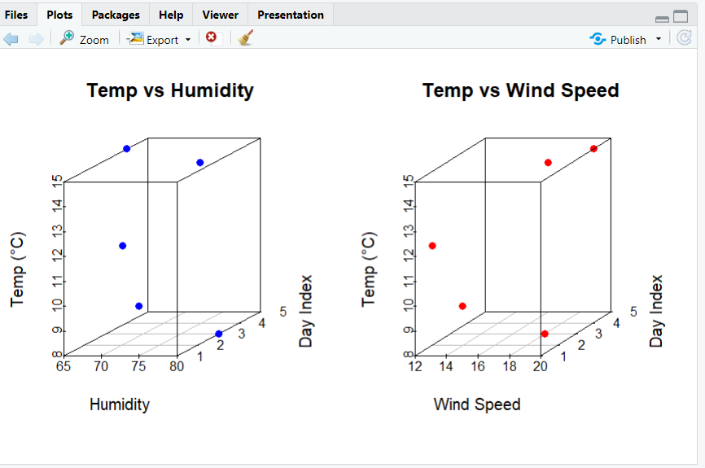
- Financial Market Data:

library(scatterplot3d)
library(plotly)
date <- as.Date(c('2023-01-01','2023-01-02','2023-01-03','2023-01-04','2023-01-05'))
stock_price <- c(100, 102, 98, 105, 108)
volume_traded <- c(2.5, 3.0, 2.2, 2.8, 3.5)
market_cap <- c(500, 510, 490, 525, 540)
df <- data.frame(date, stock_price, volume_traded, market_cap)
print(df)

# 1. Relationship between Stock Price, Volume, and Market Cap
plot(df$date, df$stock_price, type="o", col="red", ylim=c(90,120),
xlab="Date", ylab="Values", main="Stock Price, Volume & Market Cap")
lines(df$date, df$volume_traded*30, type="o", col="blue") # scaled for visibility
lines(df$date, df$market_cap/10, type="o", col="green")
legend("topleft", legend=c("Stock Price","Volume*30","Market Cap/10"),
col=c("red","blue","green"), lty=1, pch=1)

# 2. 3D Scatter Plot
scatterplot3d(df$volume_traded, df$market_cap, df$stock_price,
color="purple", pch=19,
xlab="Volume Traded (millions)", ylab="Market Cap ($)", zlab="Stock Price ($)",
main="3D Scatter: Stock Price vs Volume & Market Cap")

# 3. Check for clustering/outliers (via correlation + print summary)
print("Correlation Matrix:")
print(cor(df[,2:4]))
print("Summary:")
print(summary(df))

# 4. 3D Surface Plot — Market Cap vs Stock Price & Volume
plot_ly(df, x=~stock_price, y=~volume_traded, z=~market_cap, type="surface",
colors=colorRamp(c("skyblue","orange","red"))) %>%
layout(title="3D Surface: Market Cap vs Stock Price & Volume",
scene=list(xaxis=list(title="Stock Price ($)"),
yaxis=list(title="Volume Traded (millions)"),
zaxis=list(title="Market Cap ($)")))

# 5. Compare 3D Plots — Stock Price vs Volume & Market Cap
par(mfrow=c(1,2))
scatterplot3d(df$volume_traded, 1:5, df$stock_price, color="blue", pch=19,
xlab="Volume Traded", ylab="Day Index", zlab="Stock Price ($)",
main="Stock Price vs Volume")
scatterplot3d(df$market_cap, 1:5, df$stock_price, color="red", pch=19,
xlab="Market Cap ($)", ylab="Day Index", zlab="Stock Price ($)",
main="Stock Price vs Market Cap")

output:
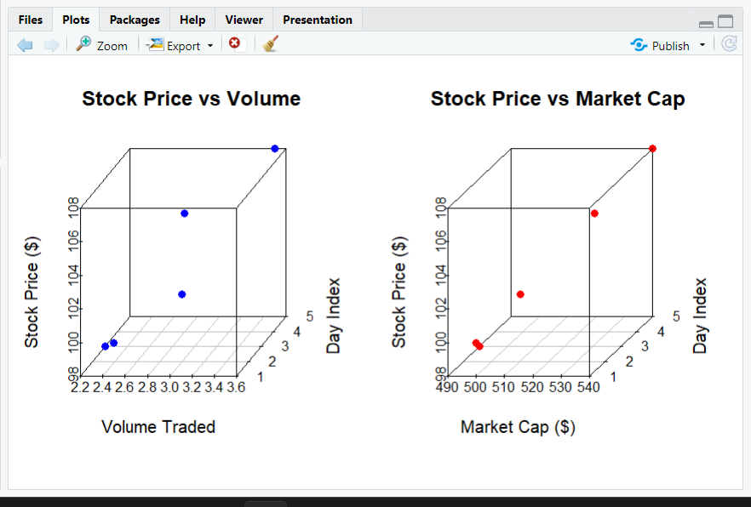

- Consumer Survey Data:

library(scatterplot3d)
library(plotly)
product <- c("A", "B", "C", "D", "E")
price <- c(50, 70, 60, 45, 55)
rating <- c(4.2, 3.8, 4.0, 4.5, 3.9)
age_group <- c("25-35", "35-45", "18-25", "45-55", "25-35")
# Convert age group to numeric midpoints (for plotting)
age_mid <- c(30, 40, 21, 50, 30)
df <- data.frame(product, price, rating, age_group, age_mid)
print(df)

# 1. Ratings vs Price and Age Group
plot(df$price, df$rating, type="o", col="blue", pch=19,
xlab="Product Price ($)", ylab="Rating (out of 5)",
main="Product Rating vs Price and Age Group")
text(df$price, df$rating+0.05, df$age_group, cex=0.8)
grid()

# 2. 3D Scatter Plot
scatterplot3d(df$price, df$age_mid, df$rating,
color="purple", pch=19,
xlab="Price ($)", ylab="Age (midpoint)", zlab="Rating (out of 5)",
main="3D Scatter: Rating vs Price & Age Group")

# 3. Correlation between Price, Age, and Rating
print("Correlation Matrix:")
print(cor(df[,c("price","age_mid","rating")]))

# 4. 3D Surface Plot — Rating vs Price & Age Group
plot_ly(df, x=~price, y=~age_mid, z=~rating, type="surface",
colors=colorRamp(c("skyblue","orange","red"))) %>%
layout(title="3D Surface: Rating vs Price & Age Group",
scene=list(xaxis=list(title="Price ($)"),
yaxis=list(title="Age (midpoint)"),
zaxis=list(title="Rating (out of 5)")))

# 5. Compare 3D Plots — Rating vs Price & Rating vs Age
par(mfrow=c(1,2))
scatterplot3d(df$price, 1:5, df$rating, color="blue", pch=19,
xlab="Price ($)", ylab="Product Index", zlab="Rating",
main="Rating vs Price")
scatterplot3d(df$age_mid, 1:5, df$rating, color="red", pch=19,
xlab="Age (midpoint)", ylab="Product Index", zlab="Rating",
main="Rating vs Age Group")
output:
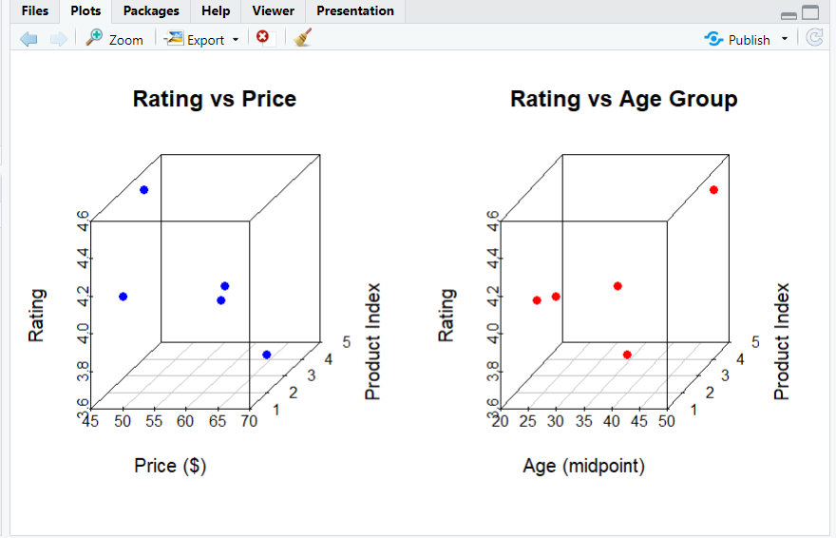
- Environmental Data:

# Install required packages (run once)
install.packages("plotly")

# Load library
library(plotly)

# Dataset
data <- data.frame(
Location = c("A", "B", "C", "D", "E"),
Temperature = c(15, 20, 18, 12, 17),
Humidity = c(65, 70, 68, 60, 72),
CO2_Levels = c(400, 450, 420, 380, 430)
)

# 1. Check how CO2 varies with temperature and humidity
print("Relationship between CO2 levels, Temperature, and Humidity:")
print(cor(data$CO2_Levels, data$Temperature))
print(cor(data$CO2_Levels, data$Humidity))

# 2. 3D Scatter Plot
scatter3d <- plot_ly(
data,
x = ~Temperature,
y = ~Humidity,
z = ~CO2_Levels,
type = "scatter3d",
mode = "markers+text",
text = ~Location,
marker = list(size = 6, color = ~CO2_Levels, colorscale = "Viridis")
) %>%
layout(title = "3D Scatter Plot: CO2 vs Temperature and Humidity",
scene = list(
xaxis = list(title = "Temperature (°C)"),
yaxis = list(title = "Humidity (%)"),
zaxis = list(title = "CO2 Levels (ppm)")
))
scatter3d

# 3. Spatial pattern (using same 3D scatter plot visually)

# 4. 3D Surface Plot
surface_plot <- plot_ly(
x = ~data$Temperature,
y = ~data$Humidity,
z = ~data$CO2_Levels,
type = "surface",
colorscale = "Viridis"
) %>%
layout(title = "3D Surface Plot: CO2 Levels with Temperature and Humidity",
scene = list(
xaxis = list(title = "Temperature (°C)"),
yaxis = list(title = "Humidity (%)"),
zaxis = list(title = "CO2 Levels (ppm)")
))
surface_plot

# 5. Compare 3D plots separately
# CO2 vs Temperature
plot1 <- plot_ly(
data, x = ~Temperature, y = ~CO2_Levels,
type = "scatter3d", mode = "lines+markers",
marker = list(color = 'red', size = 5)
) %>%
layout(title = "CO2 Levels vs Temperature",
scene = list(
xaxis = list(title = "Temperature (°C)"),
yaxis = list(title = "CO2 Levels (ppm)")
))

# CO2 vs Humidity
plot2 <- plot_ly(
data, x = ~Humidity, y = ~CO2_Levels,
type = "scatter3d", mode = "lines+markers",
marker = list(color = 'blue', size = 5)
) %>%
layout(title = "CO2 Levels vs Humidity",
scene = list(
xaxis = list(title = "Humidity (%)"),
yaxis = list(title = "CO2 Levels (ppm)")
))

plot1
plot2

Output:
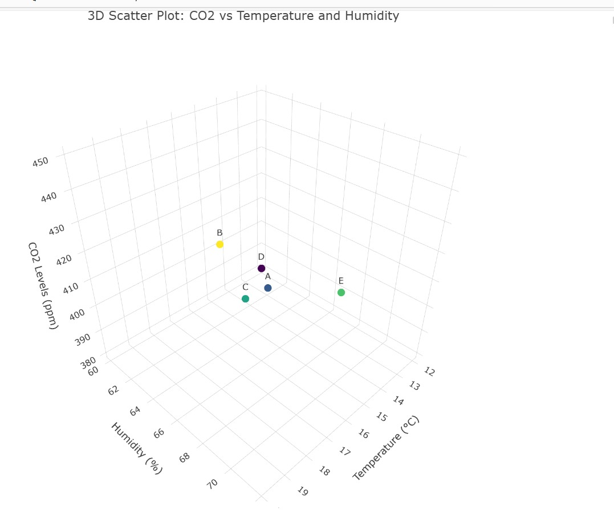

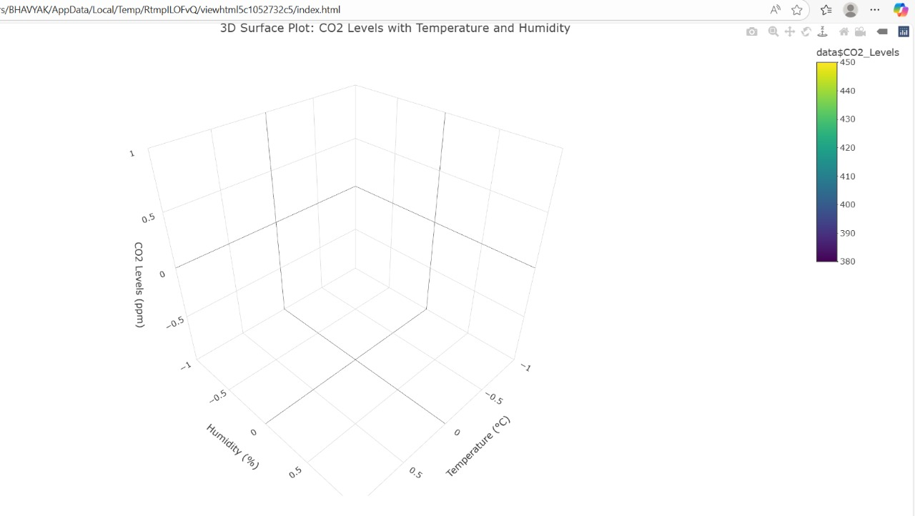
- Academic Performance Data

library(plotly)
data <- data.frame(
Student = c("A", "B", "C", "D", "E"),
Math_Score = c(85, 72, 90, 78, 88),
Science_Score = c(78, 85, 80, 75, 82),
Attendance = c(95, 92, 98, 85, 93)
)

# 1. Check correlation between science score, math score, and attendance
print("Correlation between Science, Math, and Attendance:")
print(cor(data$Science_Score, data$Math_Score))
print(cor(data$Science_Score, data$Attendance))

# 2. 3D Scatter Plot
scatter3d <- plot_ly(
data,
x = ~Math_Score,
y = ~Attendance,
z = ~Science_Score,
type = "scatter3d",
mode = "markers+text",
text = ~Student,
marker = list(size = 6, color = ~Science_Score, colorscale = "Viridis")
) %>%
layout(
title = "3D Scatter Plot: Science Score vs Math Score and Attendance",
scene = list(
xaxis = list(title = "Math Score"),
yaxis = list(title = "Attendance (%)"),
zaxis = list(title = "Science Score")
)
)

scatter3d

# 4. 3D Surface Plot
surface_plot <- plot_ly(
x = ~data$Math_Score,
y = ~data$Attendance,
z = ~data$Science_Score,
type = "surface",
colorscale = "Viridis"
) %>%
layout(
title = "3D Surface Plot: Science Score with Math Score and Attendance",
scene = list(
xaxis = list(title = "Math Score"),
yaxis = list(title = "Attendance (%)"),
zaxis = list(title = "Science Score")
)
)
surface_plot

# 5. Compare 3D plots separately

# Science vs Math
plot1 <- plot_ly(
data,
x = ~Math_Score,
y = ~Science_Score,
type = "scatter3d",
mode = "lines+markers",
marker = list(color = 'red', size = 5)
) %>%
layout(
title = "Science Score vs Math Score",
scene = list(
xaxis = list(title = "Math Score"),
yaxis = list(title = "Science Score")
)
)

# Science vs Attendance
plot2 <- plot_ly(
data,
x = ~Attendance,
y = ~Science_Score,
type = "scatter3d",
mode = "lines+markers",
marker = list(color = 'blue', size = 5)
) %>%
layout(
title = "Science Score vs Attendance",
scene = list(
xaxis = list(title = "Attendance (%)"),
yaxis = list(title = "Science Score")
)
)

plot1
plot2

Output:

